CAREER ASSESSMENT

INSTRUCTIONS: For this assignment students will research and identify a longer-term career goal. Towards this end students should brainstorm the following:

- List three things that interest you the most or that you are passionate about doing (doesn’t necessarily have to be a specific job);
- Access the following links for guidance on what to look for in identifying a future profession, or getting an idea where you may excel in:
  - http://lifehacker.com/top-10-ways-to-find-your-career-path-1628537579
  - http://www.helpguide.org/life/finding_career.htm;
  - http://money.usnews.com/money/blogs/outside-voices-careers/2010/12/06/how-to-choose-a-career-thats-best-for-you

Based on the information or insight gathered from the above sites:
- Identify a specific professional title/position in an industry that interest you.
- Based on the profession or position identified, conduct research to determine the following:
  - General Job Description for the profession/position selected;
  - Requirements for the chosen profession/position;
  - Job outlook for the profession/position selected.

Suggested site to research this information is: http://www.dol.gov/dol/topic/statistics/occupations.htm

In ESSAY format, answer the following questions:

- Paragraph 1 Introduction:
  - In three to four sentences, identify and give a brief description of your chosen profession, and what led you to select it.

- Paragraph 2: Discuss the qualifications of your chosen profession.
  - What educational requirements and aptitudes are needed?
  - How do you plan to meet the requirements of this profession?
  - What personality characteristics and values are commonly found in people entering this profession? Do you feel you possess these characteristics?
  - What is the employment outlook for this job?
  - Identify a professional association for this field. What is the association and how might it be beneficial for you to join? Is joining as a student an option?

- Paragraph 3: Complete a SWOT Analysis (described in Ch. 6). The SWOT analysis should reflect your personal strengths and weaknesses (internal) and the opportunities and threats (external to you) in the career area you have selected. You might consider this exercise as part of a marketing plan for your own career.

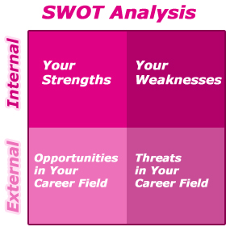

- Paragraph 4 Dream Job, Dream Company
  - Identify a company that hires people for the job/career you have selected. Look at the company’s website and/or job search sites such as Monster, to see if they are currently hiring for the position. Discuss whether or not the skill set, characteristics and education you described above, are included in the company’s job description and requirements.
  - What makes this company a good one to work for? Read Section 7.4 in your text and describe any benefits outlined in the text, which are offered by the company you identified.
  - Search the company website for “diversity”. Does the company value diversity and does that make a difference to you?
  - Lastly, look at the company’s senior management and board of directors. Is the group as diverse as you would expect given what you found on their web site about diversity?
- Paragraph 5 Conclusion: Based on your research and self-analysis:
  - Is this profession still of interest? If not, why?
  - If it does still interest you, what is one step you can take this year to help prepare yourself for that career?
FORMAT:
- Essay format; approximately three pages.

